CRICH MINERAL RAILWAYS – THE TWO GANG ROADS
Introduction
There were 2 industrial railways transporting limestone from Cliff Quarry and two smaller quarries below Crich village to the Bullbridge Lime Kilns, Canal and Rail Transport links:
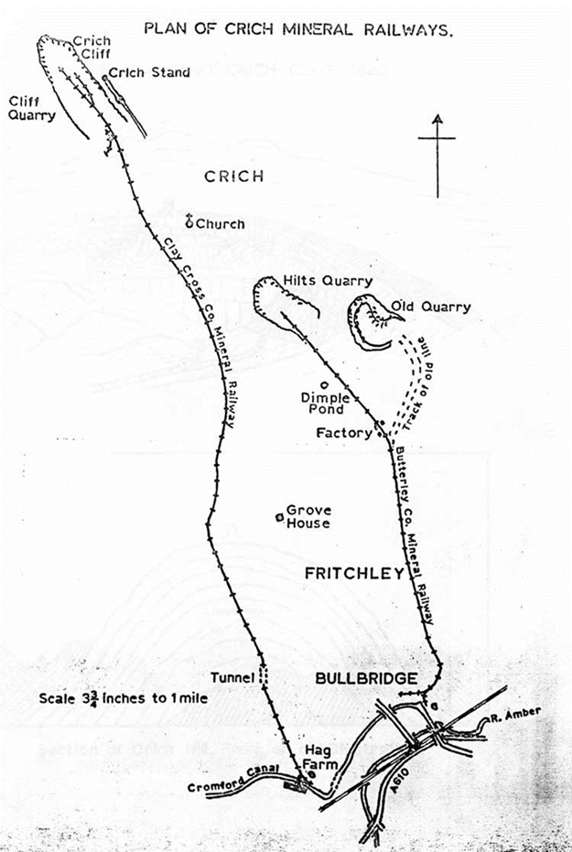
- The Outram / Butterly Co. Mineral Railway (Gang Road). 1793 -1933
This was the first railway to be operational, running from Crich on an Easterly route through Fritchley to Bullbridge. Much of the route and the famous Fritchley Tunnel are visible. The route has been designated a Scheduled Monument. It is also famous for the introduction of the Brunton’s Walking Locomotive in 1813 – the revolutionary locomotive successfully pulled the empty wagons back to the quarries for many months.

2. The Stephenson / Clay Cross Co. Railway from Cliff Quarry 1841 -1957
The Clay Cross Company railway was built in 1841 to convey limestone from Cliff Quarry at Crich to Amber Wharfe on the Cromford Canal. It followed a Westerly route around Crich village and keeping to the West of Fritchley. The line was built by George Stephenson, one of the partners in the Clay Cross Company, which was developing an extensive mining and iron making industry in this area. Little remains of the structures along this line.

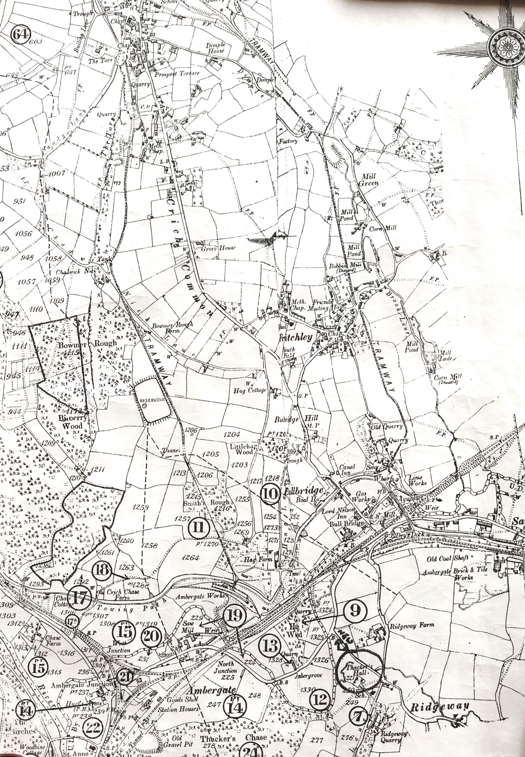
An 1880 (?) OS Map showing the routes of the two Tramways to Bullbridge

- OUTRAM – The Butterly Railway from the Hilts and Warner Quarries – The Butterly Gang Road. 1793 -1933
Text and photos mainly from https://butterleygangroad.co.uk/
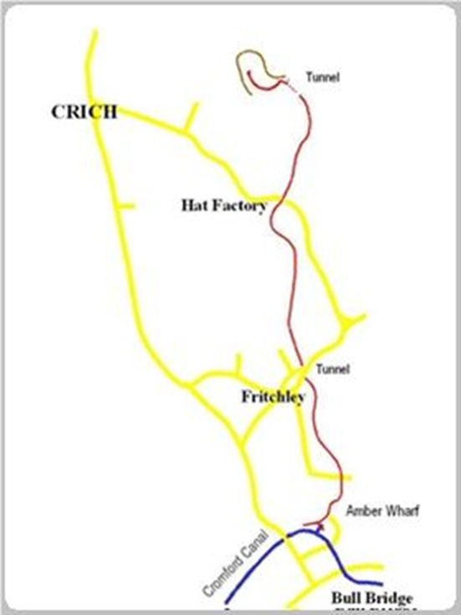
The Butterley Gang Road or Crich Railway, as it was then known, was built for Benjamin Outram & Co. to bring limestone down from the Hilts and Warner quarries and mines to the Canal at Bullbridge. From there the stone was either sold as burnt lime or transported by canal boat to the Butterley Works near Ripley where it was used in making iron products. The line was about 1 mile long. The Gang Road was originally a horse-drawn tramway built as a 3ft 10inch (1.17m) gauge plate way. It was later steam-worked and closed in 1933. It ran from Hilt's quarry and Warner quarry to limekilns and sidings at Bull Bridge. It was in operation from 1793.
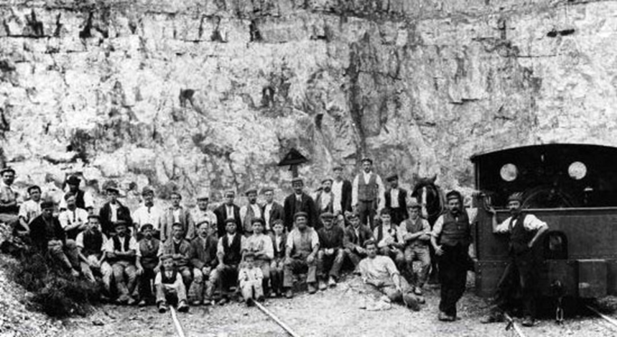

The Butterley Gang Road was a one of the first railways in the East Midlands, maybe the world, where a “steam locomotive” operated successfully. This is recognised in the Records of Scheduled Monuments - Record MDR13268 - Butterley Gang Road and Fritchley Tunnel, Crich and Ripley

In 1985 the embanked section of the gang road to the north of the Fritchley Tunnel was listed at Grade II. In 2015, following excavation and investigation, the Fritchley Tunnel was designated a Scheduled Monument, having been recognised as the earliest railway tunnel in the world.
Details – “PRINCIPAL ELEMENTS” The scheduled monument comprises the route of the Butterley Gang Road, as defined for the most part by sections of surviving stone boundary walling. It extends from the entrances to the former Hilts and Warner quarries at its northern end (both now infilled), to the approach to the Amber Wharf of the Cromford Canal at Bullbridge at its southern end.

This line is Scheduled for the following principal reasons:
* Rarity: as a rare surviving example of a late C18 and early C19 gang road, an early railway on which wheeled wagons were used to transport limestone from quarries in Crich, Derbyshire to the Cromford canal.
* Survival: the gang road survives in legible form throughout almost its entire length and includes boundary walling, an incline, embankments, cuttings, overbridges, buried track bed features and a railway tunnel.
* Period: for its early date in the context of the development of the railway transport network in England, and the inclusion within its length of what is believed to be the earliest railway tunnel in the world.
* Documentation: for its documented association with the pioneering railway engineer and surveyor Benjamin Outram, a key figure in the early development of rail transportation in England.
* Diversity of Features: for the exceptional survival of a variety of standing and buried features which collectively help us to understand the construction, use and function of the gang road in the wider industrial landscape.

The World’s Oldest Railway Tunnel

In Fritchley village the Butterley Gang Road passed under a road junction by means of a tunnel that emerged in the field a few metres beyond the road. This tunnel has survived and is now officially recognised by the Guinness World Book of Records as the world's oldest railway tunnel.
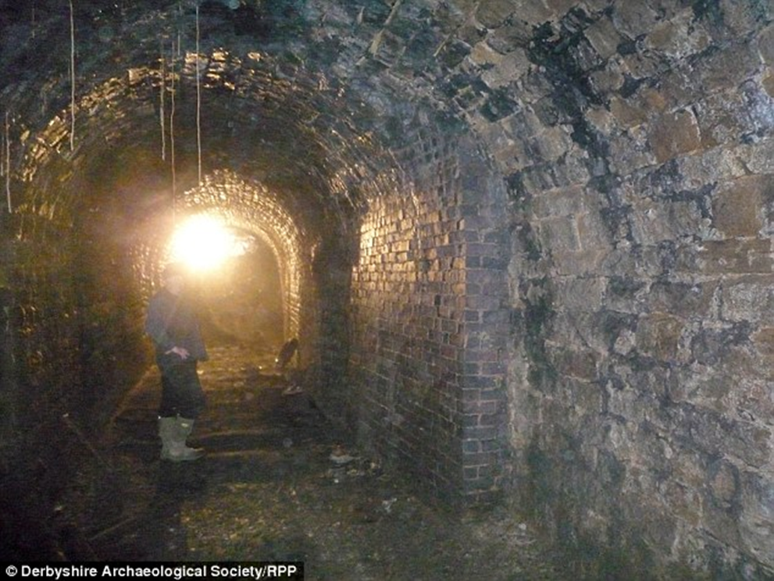
Fritchley Tunnel
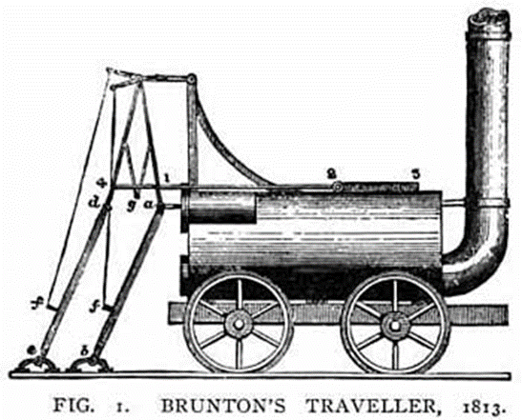
Brunton’s Walking Locomotive. (1813 -1869?)
Brunton's Walking Locomotive ran on the Butterley Gang Road for several months.

William Brunton, who was working as an engineer for the Butterley Company in 1813, was allowed to use the company facilities to build and test a steam locomotive. Called the 'Mechanical Horse' or 'Traveller', this technology solved the problem that other early locomotives had experienced of breaking the fragile cast iron rails. This extraordinary machine, patent No. 3,700 (1813), which propelled itself by a pair of 'ski-sticks’, was built at the Butterly works at Ripley in 1813.It appears to have operated successfully on the Crich Railway for several months pulling empty wagons back up to the quarry at a steady walking pace. This was quite an achievement given the ruling gradient was about 1 in 35, and it was many years before conventional steam locomotives were built that could tackle such grades. Unfortunately, a similar machine blew up, killing eleven men at a colliery in the north of England and Brunton’s steam engine was withdrawn from service. The railway was subsequently rebuilt as a conventional narrow gauge steam mineral railway and operated as such until 1933.
The Butterly Gang Road update.
The first more conventional steam locomotive commenced operation on the line in 1869, by which time Amber Wharf had developed into a major industrial processing and transhipment complex. There is no evidence for any locomotive, other than Brunton’s 'Horse', before 1869. The builder of the first more traditional locomotive is probably Chaplins of Glasgow. This also dates the engine shed. The incline to Hilt’s Quarry was singled and converted to locomotive operation in 1894 when 'Fitz' arrived.
The early line had a gradient of 1 in 30 (30%) down from Hilt’s quarry. The Hilt's incline had a gradient of 1 in 15 (6%) that extended beyond the double track section. There is no evidence for an incline on the approach to Amber Wharf. The gradient here is a relatively gentle 1 in 40 (2.5%) - the bridge over Drover's Lane had been raised by about 15 feet c. 1900. The double track here was to separate incoming from outgoing wagons.
Remains exist of the mine that became a tunnel at the entrance to Warner Quarry. The top was removed c. 1900 but part of the sidewalls remain.
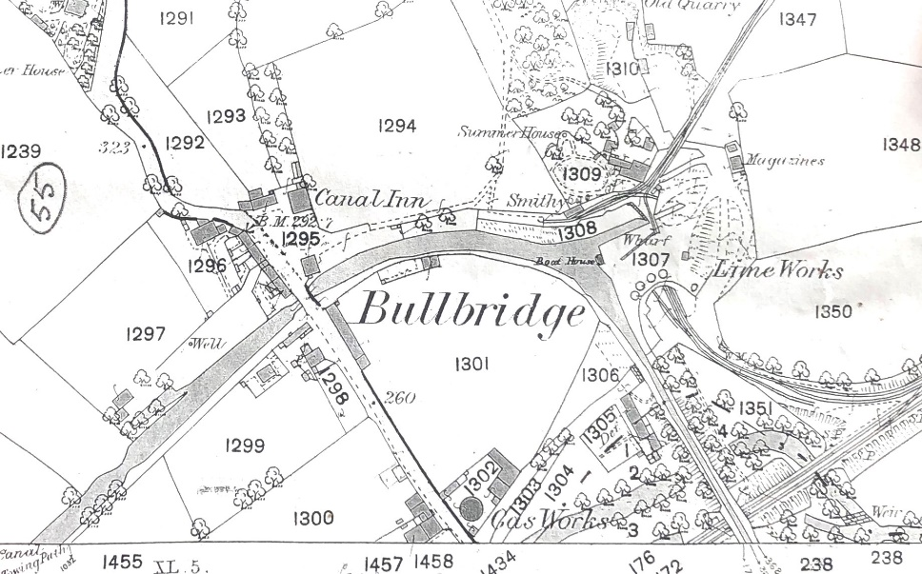
Amber Wharf become a complex limestone processing site by 1900. It housed a bank of six lime kilns, two sets of multi-track sidings linking the production areas to the main Midland Railway line, and a twin track section of the gang road serving different areas of the site. In 1904 the site was modernised, with the installation of conveyors to deliver quarry stone to the kilns from the former gang road. However, by 1933, the business had declined, and the lime works, together with the quarry and the steam railway linking it to the wharf was closed. The Butterley Company was slow to sell off the old infrastructure. Most of this route survives untouched but overgrown and derelict as illustrated in the following “before and after” photos.

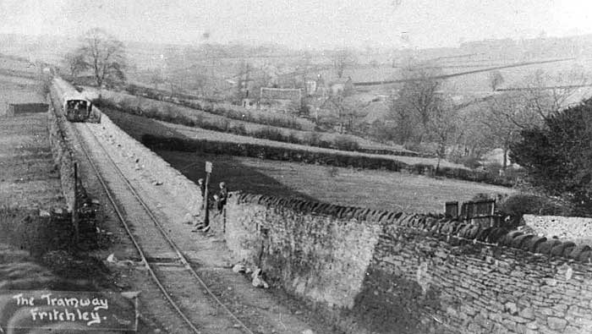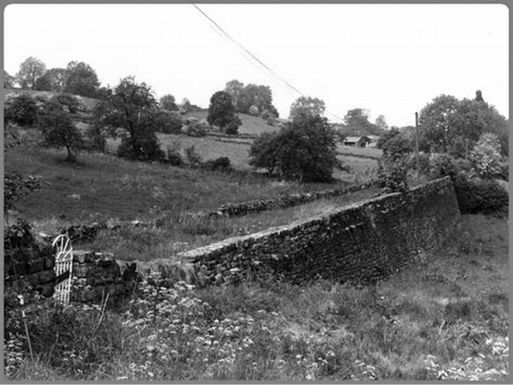

2 STEPHENSON - Clay Cross Co. Railway from Cliff Quarry 1841 -1957
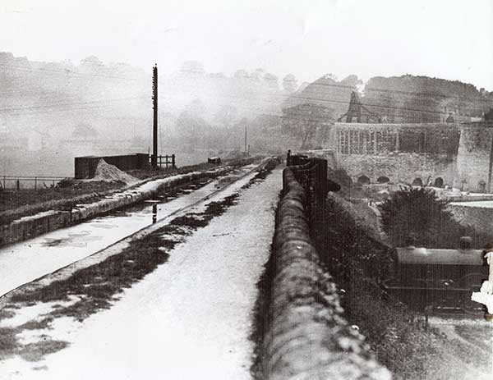
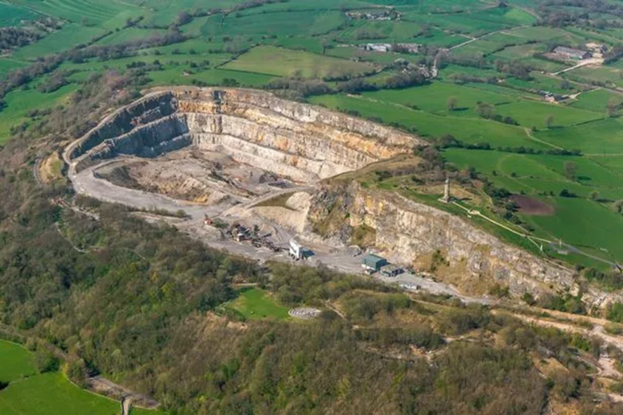

The Clay Cross Company railway was built in 1841 to convey limestone from Cliff Quarry at Crich to Amber Wharfe on the Cromford Canal.
The line was built by George Stephenson. As well as being the Engineer for the main line, he was one of the partners in the Clay Cross Company which was developing the extensive mining and iron making industry in this area. The line was built to a gauge of 1 metre, one of the earliest examples of a line built to this gauge.
George Stephenson himself superintended the construction of the railway line which included two tunnels and two self-acting inclines.
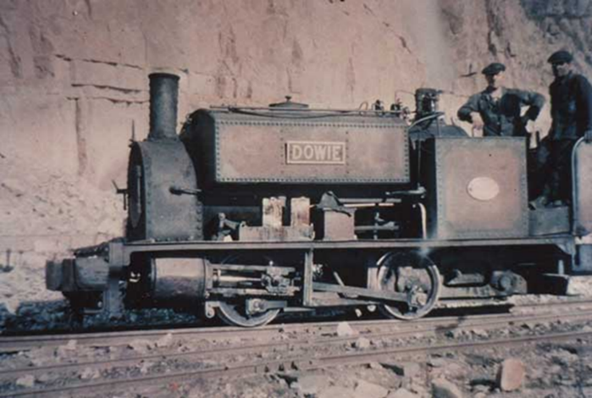
The line was horse drawn until 1893, when the first locomotive, an 0-4-0 saddle tank, was purchased from the local engineering works of Markham and Co. The locomotive was named Dowie, after the family nickname of the company chairman’s daughter in law.
From 1952, the line progressively converted to diesel power, using 3No. 48HP Ruston & Hornsby locomotives. The first two were named GMJ (the husband of Dowie) and Ted (the quarry manager). The final one, delivered in 1956, was again named Dowie.

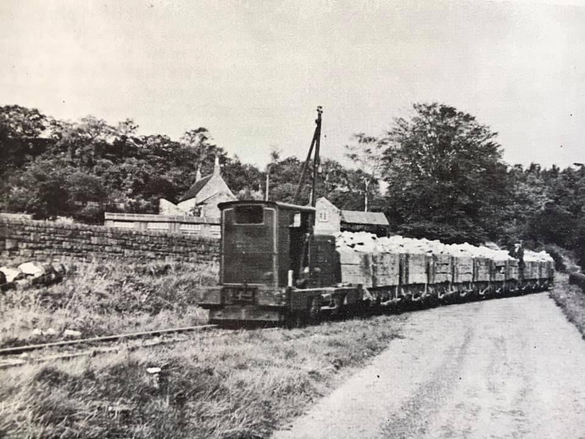
Diesel loco loaded with limestone crossing Nick Lane at Bowmer Rough Farm.
Quarry operations ceased operation in 1957, and much of the rail was bought by the Talyllyn Railway for relaying its worn-out track.
Evidence of the Line
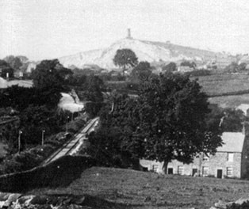
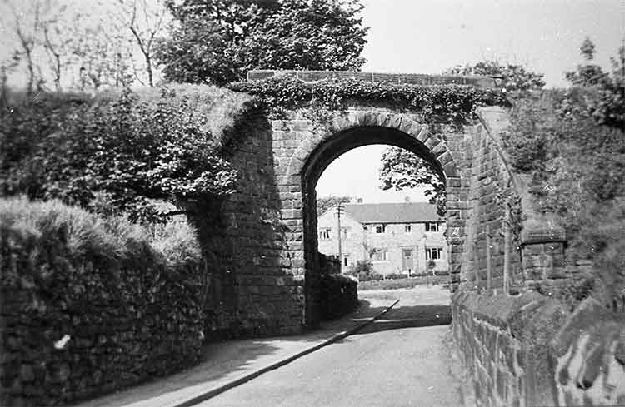
Some original buildings remain within the present Crich tramway museum complex and the bridge under the road outside of the museum is visible. The small bridge at Gost Hill (SK348543) is also clearly visible. A small loco shed at Chadwick Nick (SK 348533) survives, while the remains of the inclined plane that took the line down to the canal level are still visible. This stone bridge up Market Place was demolished to make way for houses.
This photo shows the line of the Stephenson tramway from The Tors.

RLH 1 June 2024

